**Menu for owner:**

1. **Listen to new message**: System notifies how many new messages and plays the first one. After that, the next menu:  
    1. Listen to this message again  
    2. Save this message  
    3. Delete this message  
    4. Go back to the main menu
2. **Change password**
3. **Change greeting**  
    1. Switch greeting  
    2. Record new greeting  
    3. Delete old greeting  
    4. Go back to the main menu

**Menu for administrator:**

1. Create mailbox for a new user
2. Reset a user password
3. Change a user password

**ANALYSIS PHASE**

# **Functional Specification**

Introducing the best voice mail system! This voice mail system is designed for multiple users with different intentions. The caller can leave a message for the owner in case the owner is not available. Each owner of each voicemail in the system can access the system to retrieve, save, delete messages, change password, record new greeting, delete, and change their greeting. The administrator of this voicemail system is a single entity who can add multiple owners to the system with their own extension number, together with a personal mailbox and password; he can also change any user’s password.

# **User Manual**

* *Leave a Message*: You first need to call the main number, given the owner of the number does not pick up or reject the call, the voice mail system will activate and ask you for a specific extension number whose you want to leave a message for. Next, enter the mailbox number you desire. After that, you can speak your message and hang up. However, if the mailbox is already full at the time, the system will refuse to let you leave a message.
* *Retrieve a Message*: You first need to dial your designated extension number, then your password after the prompt from the system. Next, press 1 to listen to new messages. After a new message is played, press 1 to listen to it again, press 2 to save, press 3 to delete, or press 4 to go back to the main menu.
* *Change Password*: You first need to dial your designated extension number, then your password after the first prompt from the system. Next, press 2 to change password. After the second prompt, input new password.
* *Change Greeting*: You first need to dial your designated extension number, then your password after the first prompt from the system. Then, press 3 to enter the greeting menu. Next, press 1 to switch to another greeting, press 2 to record new greeting, press 3 to delete old greeting, or press 4 to go back to the main menu.
* *Create Mailbox for a New User*: To log in as an administrator, you need to enter a single special code assigned only for the administrator. Next, press 1. After the prompt from the system, enter a new extension number you want to create. Then, enter the password for the new mailbox.
* *Reset a User Password*: To log in as an administrator, you need to enter a single special code assigned only for the administrator. Next, press 2. Then, choose the mailbox to reset password by entering its extension number. After that, the password will be reset to be the same as the extension number.
* *Change a User Password*: To log in as an administrator, you need to enter a single special code assigned only for the administrator. Next, press 3. Then, choose the mailbox to change password by entering its extension number. After that, enter the new password for that mailbox.

# **Use Cases**

### Caller Leaves a Message

1. The caller dials the main number of the voice mail system, the owner does not pick up or rejects the call.
2. The system prompts: “If you want to leave a message, please enter mailbox number followed by #.”
3. The caller inputs the extension number of the message recipient.
4. The system prompts: “You have reached mailbox of X, leave a message now.”
5. The caller speaks the message then hangs up.
6. The system saves the recorded message in the owner’s mailbox.

VARIATION 1:

1. After step 1, the mailbox is already full.
2. The system speaks: “The mailbox is full at the moment. Please call back at another time. Sorry for the inconvenience.”
3. The system disconnects the call.

VARIATION 2:

1. In step 3, the caller inputs an invalid extension number.
2. The system speaks: “You have entered an invalid mailbox number.”
3. Go back to step 2.

VARIATION 3:

1. In step 5, the caller hangs up without leaving any message.
2. Instead of step 6, the system discards the empty message.

### Owner Retrieves a Message

1. The owner dials his own extension number.
2. The system prompts: “Enter your password followed by #.”
3. The owner inputs his password.
4. The system speaks: “Press 1 to listen to new message. Press 2 to change password. Press 3 to change greeting.”
5. The owner presses 1.
6. The system speaks: “You have N new messages.”
7. The system speaks: “First new message” and plays the first new message.
8. The system speaks: “Press 1 to listen to this message again. Press 2 to save this message. Press 3 to delete this message. Press 4 to go back to the main menu.”
9. The owner presses 2.
10. The system speaks: “Message saved.”
11. Go back to step 6.

VARIATION 1:

1. In step 3, the owner inputs wrong password.
2. The system speaks: “Wrong password.”
3. Go back to step 2.

VARIATION 2:

1. In step 5, the owner presses an invalid key.
2. The system speaks: “You have entered an invalid key.”
3. Go back to step 4.

VARIATION 3:

1. In step 6, there is no new message.
2. The system speaks: “First saved message” and plays the first saved message.
3. Go to step 8.

VARIATION 4:

1. In step 9, the owner presses 1.
2. Go back to step 7.

VARIATION 5:

1. In step 9, the owner presses 3.
2. The system speaks: “Message deleted.”
3. Go back to step 6.

### Owner Changes Password

1. Follow the first 4 steps of Owner Retrieves a Message.
2. The owner presses 2.
3. The system prompts: “Enter your new password followed by #.”
4. The owner inputs his new password then hangs up.
5. The system sets new password.

VARIATION 1: (VARIATION 1 of Owner Retrieves a Message)

VARIATION 2: (VARIATION 2 of Owner Retrieves a Message)

VARIATION 3:

1. In step 4, the new password is the same as the old password.
2. The system speaks: “New password can’t be the same as old password.”
3. Go back to step 3.

### Owner Changes Greeting

1. Follow the first 4 steps of Owner Retrieves a Message.
2. The owner presses 3.
3. The system speaks: “Press 1 to switch greeting. Press 2 to record new greeting. Press 3 to delete old greeting. Press 4 to go back to the main menu.”
4. The owner presses 1.
5. The system speaks: “You have N different greetings. Press 1 or 2 or 3 to choose greeting.”
6. The owner chooses his desired greeting then hangs up.
7. The system sets new greeting.

VARIATION 1: (VARIATION 1 of Owner Retrieves a Message)

VARIATION 2: (VARIATION 2 of Owner Retrieves a Message)

VARIATION 3:

1. In step 4, the owner presses 3.
2. The system speaks: “You have N different greetings. Press 1 or 2 or 3 to delete greeting.”
3. The owner deletes a greeting then hangs up.
4. The system deletes old greeting.

VARIATION 4:

1. In step 4, the owner presses 2.
2. If the owner already has 3 greetings, the system speaks: “You reached your maximum number of greetings. To record a new greeting, delete an old greeting.” Go back to step 3.
3. If the owner has less than 3 greetings, the system speaks: “Start recording new greeting.”
4. The owner speaks the greeting then hangs up.
5. The system saves the recorded greeting.

### Administrator Creates Mailbox for a New User

1. The administrator dials the single special code assigned only for the administrator.
2. The system speaks: “Press 1 to create a mailbox for a new user. Press 2 to reset a user's password. Press 3 to change a user's password.”
3. The administrator presses 1.
4. The system prompts: “Enter a new extension number followed by #.”
5. The administrator inputs the new extension number.
6. The system prompts: “Enter password for the new mailbox followed by #.”
7. The administrator inputs the password then hangs up.
8. The system creates a new mailbox with assigned extension number and password.

VARIATION 1:

1. In step 3, the administrators presses an invalid key.
2. The system speaks: “You have entered an invalid key.”
3. Go back to step 2.

VARIATION 2:

1. In step 5, the administrators enters an existing extension number.
2. The system speaks: “This extension number already exists.”
3. Go back to step 4.

### Administrator Resets a User Password

1. Follow the first 2 steps of Administrator Creates Mailbox for a New User.
2. The administrator presses 2.
3. The system prompts: “Enter the extension number of the mailbox you want to reset password followed by #”
4. The administrator inputs the extension number then hangs up.
5. The system resets the password to the same value as the extension number.

VARIATION 1: (VARIATION 1 of Administrator Creates Mailbox for a New User)

VARIATION 2:

1. In step 4, the administrator inputs a non-existing extension number.
2. The system speaks: “This extension number does not exist in the system.”
3. Go back to step 3.

### Administrator Changes a User Password

1. Follow the first 2 steps of Administrator Creates Mailbox for a New User.
2. The administrator presses 3.
3. The system prompts: “Enter the extension number of the mailbox you want to change password followed by #”
4. The administrator inputs the extension number.
5. The system prompts: “Enter the new password followed by #.”
6. The administrator inputs the new password then hangs up.
7. The system changes the password to the new value.

VARIATION 1: (VARIATION 1 of Administrator Creates Mailbox for a New User)

VARIATION 2: (VARIATION 2 of Administrator Resets a User Password)

**DESIGN PHASE**

# **Identify Classes**

* Message
* MessageQueue
* Mailbox
* MailCenter
* Telephone
* ControlHub
* Administrator

# **Class Responsibility**

* Message contains message content.
* MessageQueue stores list of messages. It can add and remove messages.
* Mailbox keeps old and new messages in different MessageQueues. Its operations allow users to retrieve, save, or delete each message.
* MailCenter manages and controls multiple Mailboxes for different users.
* Telephone receives user input, speaks prompt and content of message.
* ControlHub gets user input from Telephone, carries out user command and records voice message.
* Administrator adds new Mailboxes into MailCenter and modifies password of individual Mailbox.

# **Class Relationship**

* MailCenter “has” Mailboxes (aggregation)
* Mailbox “has” MessageQueues (aggregation)
* MessageQueue “has” Messages (aggregation)
* ControlHub “has” a current Mailbox (aggregation)
* ControlHub “has” Telephone (aggregation)
* ControlHub “has” MailCenter (aggregation)
* ControlHub “has” an Administrator (aggregation)
* Telephone “uses” (speaks message from) ControlHub (dependency)
* ControlHub “uses” (creates) Message (dependency)
* Administrator “has” MailCenter (aggregation)
* Administrator “has” a current Mailbox (aggregation)

# **Class Diagram**

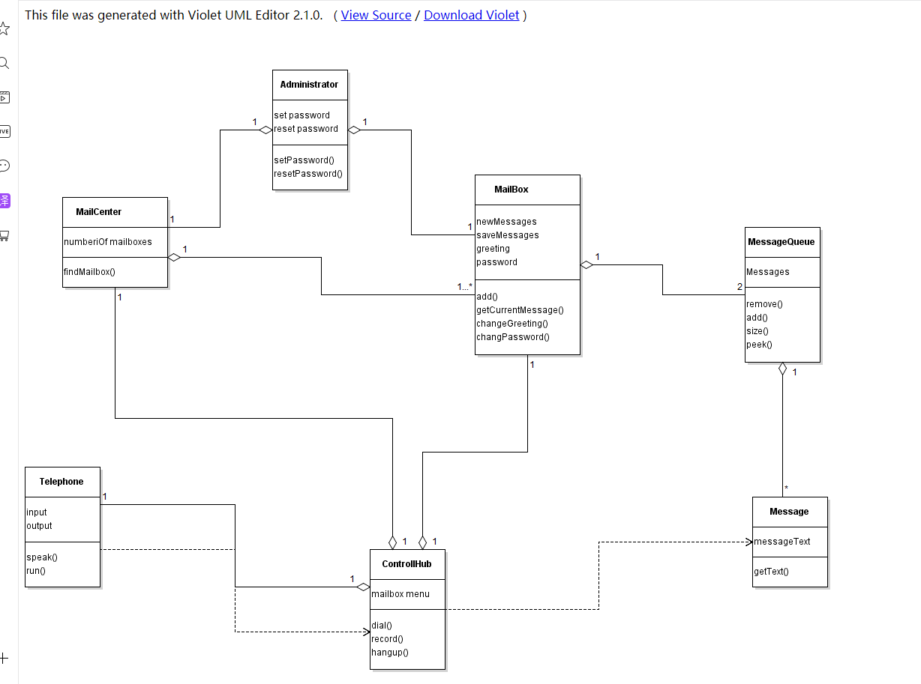

# 

# **Sequence Diagram**

### Caller Leaves a Message

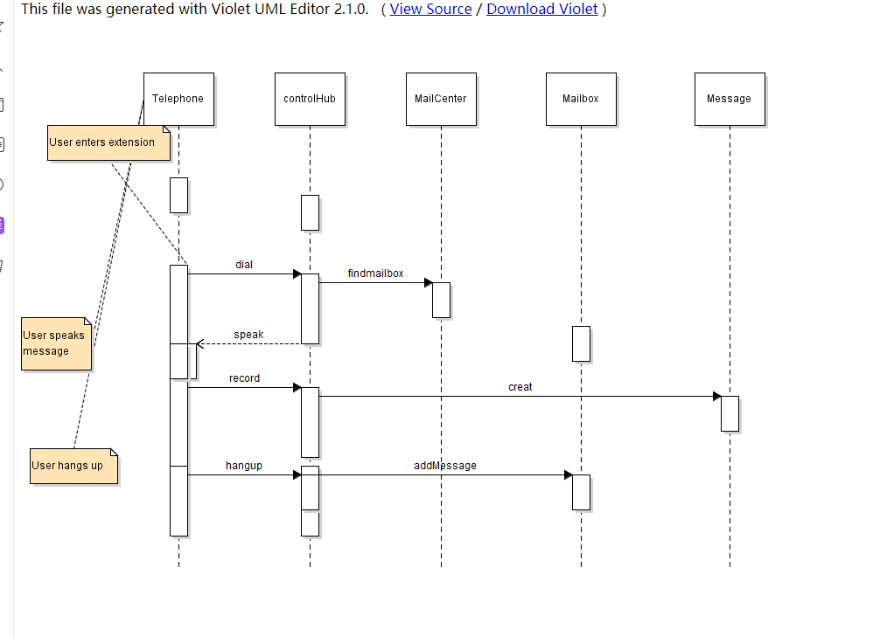

### Owner Retrieves a Message

### Administrator Handles Password and Adds New User

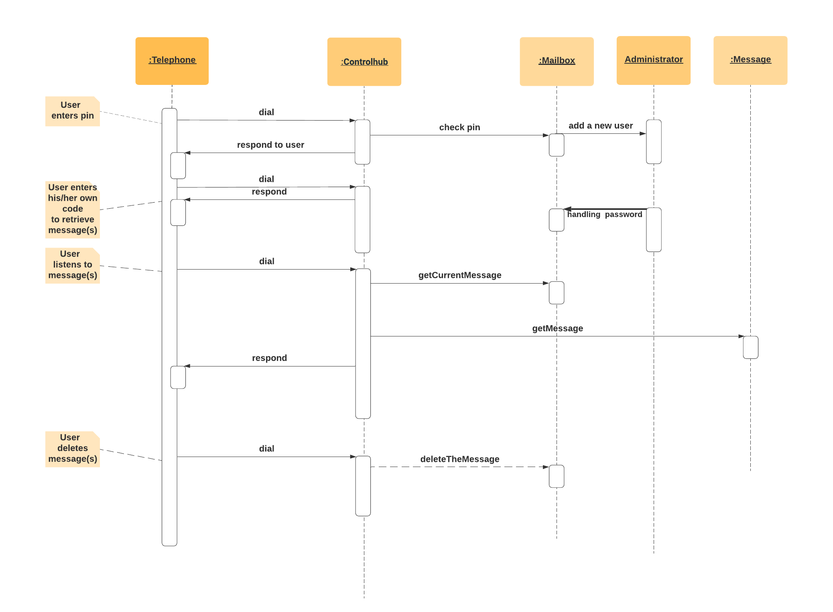

Owner Changes Password & Greeting

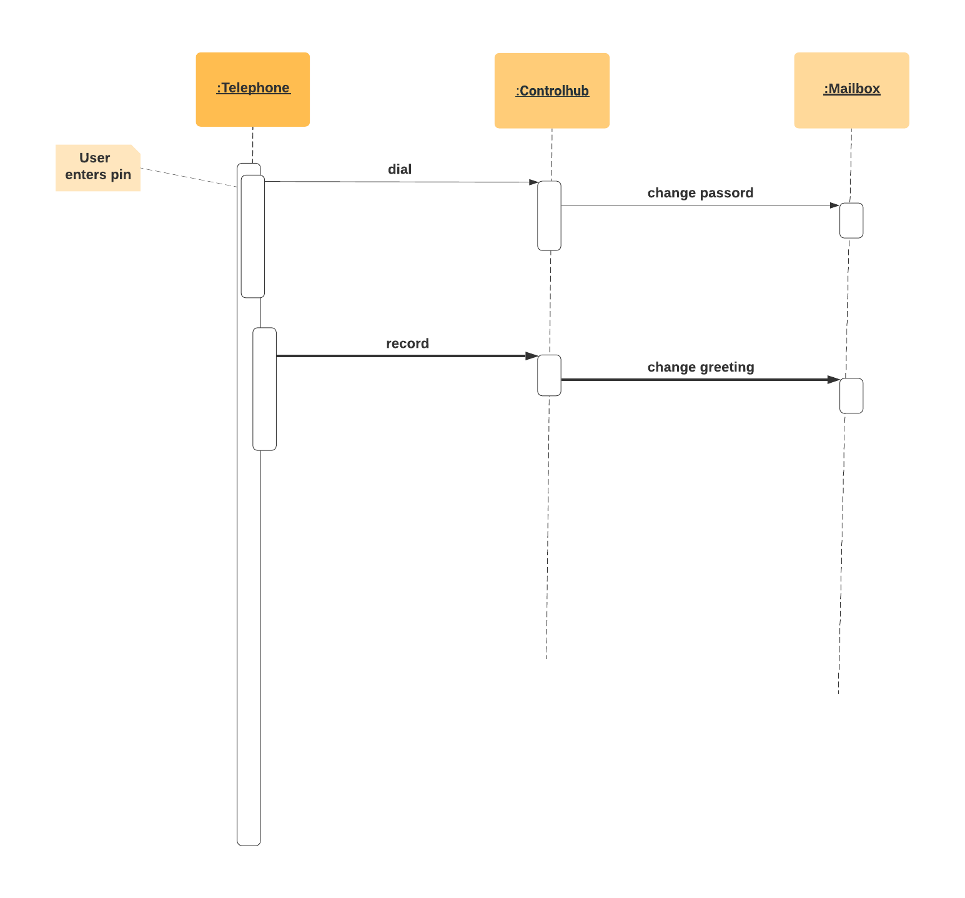

# **State Diagram**

